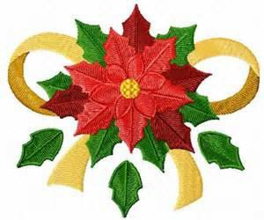

The Town of Emerald Isle
2022 Emerald Isle Parade Entry Form
Entry Deadline: November 16, 2022
19th Annual Emerald Isle Parade: 2 p.m. Saturday November 26th

Name of Entry:
Contact Name:
Company/Org:
Address:
City:
State: | Zip:
Phone: | Fax:
Email:
Entry Type: (Circle) | Commercial Civic Dignitary Non-profit Other
Entry Description:
Entry length (feet)
Will you have? | Music Dogs Horses Other

Cash Prizes for Best Decorated Floats Commercial 1st and 2nd & Non-commercial 1st and 2nd
IMPORTANT NOTE TO ALL ENTRANTS: There will be only ONE Santa Claus in the parade and he will be riding in a float at the end. All other Santa’s will be sent back to the North Pole!
You will get an email by November 23rd informing you of your lineup number.

Please complete and return this form to:
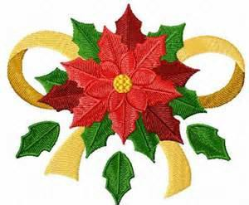
Emerald Isle Parks & Recreation
Wells
7500 Emerald Drive
Emerald Isle, NC 28594
Email: Cdooley@emeraldisle-nc.org

